MMAI 5100 T – Database Fundamentals

Assignment 1: Querying the Bakery Sales Dataset, June 7 2026.
Group 6 : Fuyao Qiu, Tianwei (Joe) Zhou, Oluwaferanmi (Feranmi) Onifade, Katya Guez

- Initial assumptions
While question 5 deals with data quality commentary in depth, we would like to express two assumptions faced with irregular data ahead of answering the assignment’s questions, as these affect the final results in some of the questions.

Assumption 1 : We accept the irregular article name “.”
Rationale : There are only 5 occurrences of this irregular article, so it will not affect our results that much since the questions focus on high-occurring quantities and articles. Since we lack further context regarding this article and that the risk of results contamination is low, we choose not to alter or subset the data set ahead of our queries. We can consider “.” as a miscellaneous, valid article.

Assumption 2 : We accept negative quantities in the dataset
Rationale : We considered whether to remove the negative values from the data set or to interpret them as refunds and/or mistake corrections. Looking at the largest negative value -200 “CAFE OU EAU” articles in ticket 179932, we noticed that the preceding ticket 179931 has +200 “CAFE OU EAU” articles entered in the same time-frame, suggesting that the 179932 negative ticket may have been an immediate correction to a 179931 ticket mistakenly entered (which sounds about right since ordering 200 coffees or water at once seems abnormal).
Furthermore, in Q5 we explore the data set’s statistical profile and confirm that the outlier values seem to balance each other out, not yielding an irregular mean or standard deviation. In fact, removing the negative values may heavily skew our values to the right.
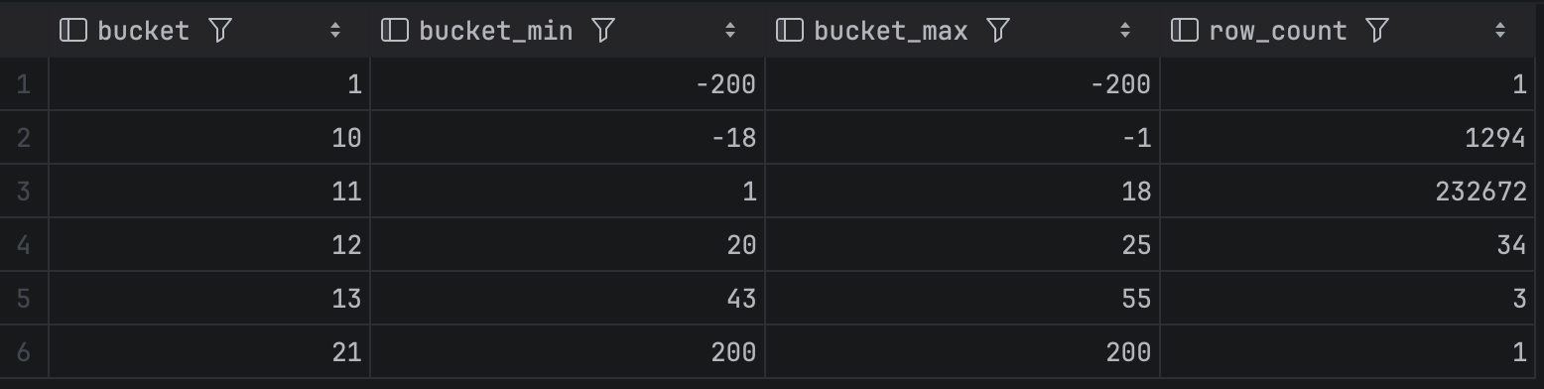
A last comment, the query for revenue across the .sql file is (quantity * unit_price), which for negative quantities will yield negative revenue, correctly adjusting our revenue totals.
For all these reasons, we knowingly accept negative quantities in the dataset.
- Question 1 : Top 3 Most Sold Items by Year-Month
The result is a 64-row table of top 3 most sold items over the course of 21 months.
The table has an additional record (compared to the expected 63 rows) in April 2021 because there is a tie for 3rd place we used the DENSE_RANK() function rather than the RANK() function.
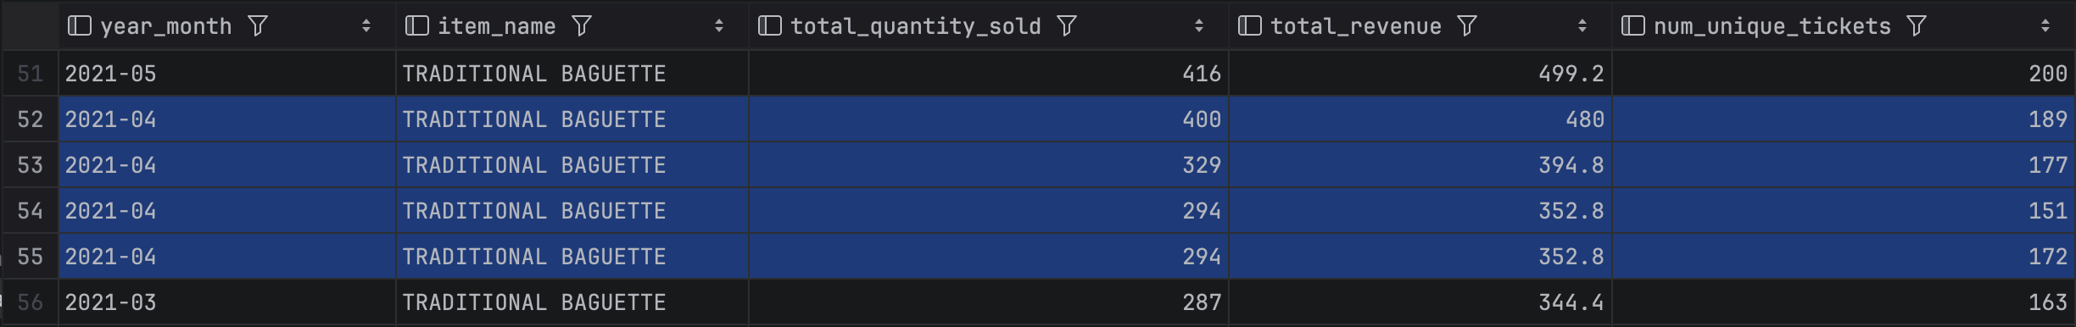
We made this choice because in case of a tie in the top 3, we would lose information, and knowing all top-selling products is useful information for a business owner.
Another comment is we use DESC ordering for dates because people are usually more interested in the latest dates when looking at business data.

- Question 2 : Tickets with 5 or More Unique Articles
The result is a 123-row table of information grouped by ticket_id and filtered to show those with 5 or more unique articles contained in them, for December 2021.
Several filtering methods worked for this query to isolate ticket in December 2021. Our group members had different approaches, some converting the sale_date TO_CHAR and comparing it with '2021-12', and others using CTEs to subset the December 2021 records before querying this temporary table.
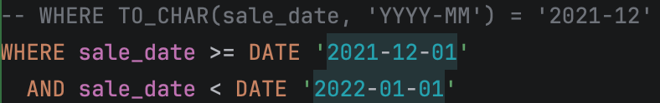
Ultimately, we chose the DATE comparison as shown here because it was the code that yielded the best performance in runtime.

- Question 3 : Most Popular Hour for Traditional Baguette Sales
The most popular hour for traditional baguette sales during the month of July, across all years, was 11AM with 4060 baguettes sold in total (over the course of two months of July).

- Question 4 : Busiest Two-Hour Window for Sales
After inspecting the opening and closing times of the store, we notice that the store opens at 7AM (the first sale is at 07:01) and it closes at 8PM but the last sale is at 20:01.
We decided to include the 20:00 and 20:01 times’ data with the preceding timeslot in order to account for those final late sales. Business-wise, this seemed like a reasonable assumption to make.
- Question 5 : Data Quality Checks
The data was checked for missing values, duplicate records, negative or zero quantities and prices, invalid dates and times, outliers. An additional exploration of price fluctuation over time was also added out of curiosity.
The code is well documented for comments, and some were already made in the 0. Introduction above, but we add a couple of comments below regarding the topic duplicate records.

When searching for duplicate records, we noticed that there were 1155 records with at least one duplicate across the full row. We were originally worried about data quality because it seemed surprising that they would have not only the same article name and price, but also the same ticket number and exact sale time.
After discussion, we interpreted the following :
- The tipping system does not seem to aggregate all the time. The cashier may tip the items one by one, and depending on the order, our interpretation is that if two same articles were tipped in a row, they aggregate, and if not, they don’t.
- The sale_time is the same value for all articles in the ticket, we interpret this as the sale_time registering only once, after the ticket is complete and moves to payment (or is paid), which makes sense to avoid registering copious amounts of times for relatively no reason.
Furthermore, we noticed the “COUPE” article showed up a lot. After isolating it, we realized it appeared 804 times in our 1155, making up close to 70% of observed duplicates.
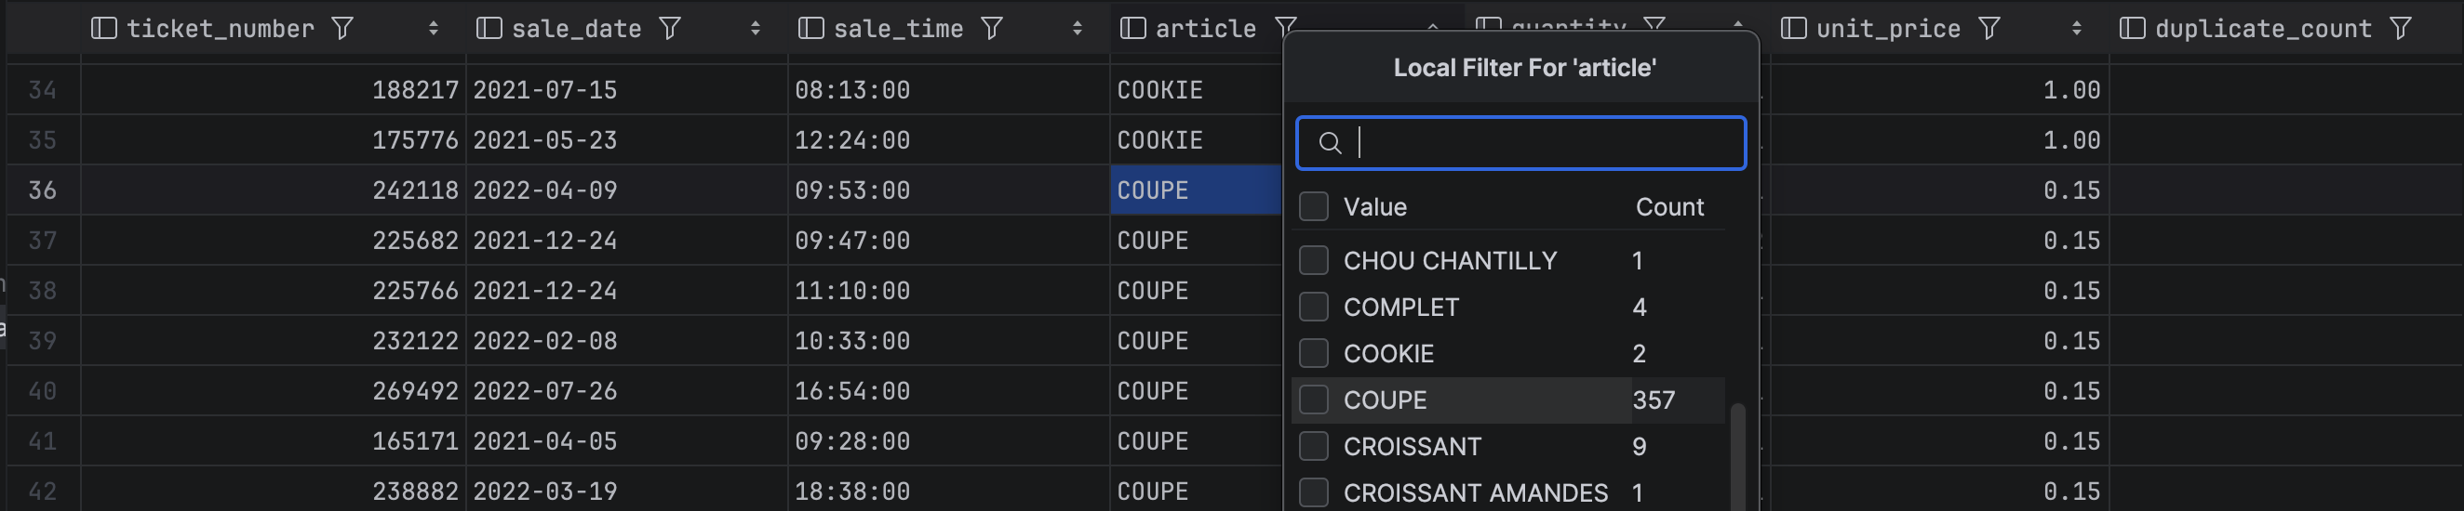
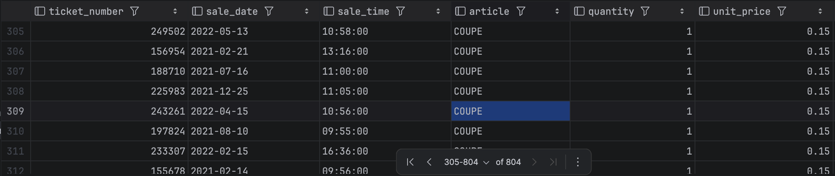
With a bit of French translation, the word “COUPE” means “cut” as in cutting the bread. This makes sense it a “COUPE” was tipped after each bread article the customer requested to have cut, and the 0.15 price makes sense as well, echoing our previous interpretation about the aggregation mechanism of the tipping system and the tipping order of an “article” (or rather a service) such as “coupe”.
The remaining 351 records aren’t too big a deal over 2 years of data, it makes sense a customer might add (and the cashier would tip) a last minute duplicate article once in a while.

